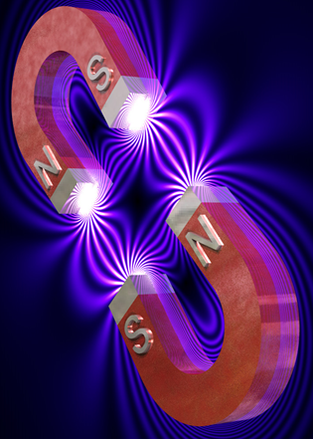

[**VISUAL PHYSICS ONLINE**](http://www.physics.usyd.edu.au/teach_res/hsp/sp/spHome.htm)

**MODULE 4.2**

**MAGNETISM**

**PERMANENT MAGNETS**

Powerful magnets are essential components in motors and generators. Some electric motors and generators rely upon a combination of a permanent and an electromagnet. An electric motor converts electrical energy into mechanical energy by the torque acting on a conductor carrying an electric current in a magnetic field. A generator converts mechanical into electrical energy by moving a conductor through a magnetic field. A neurosurgeon can guide a pellet through brain tissue to inoperable tumours, pull a catheter into position, or implant electrodes while doing little harm to the brain by utilizing the properties of magnetic forces associated with magnetic fields.

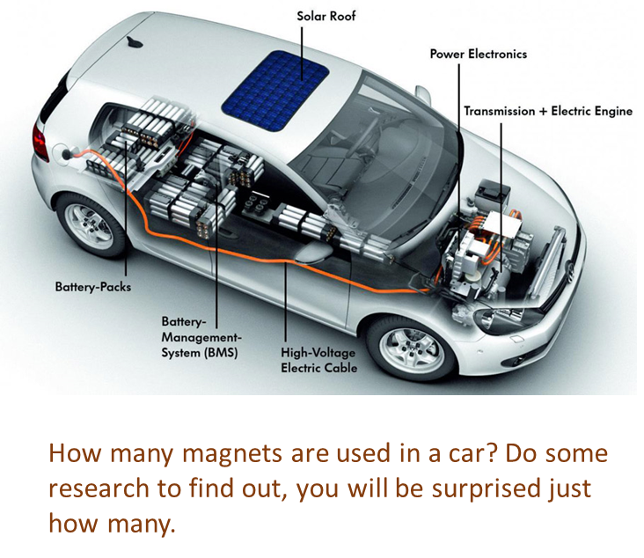

*But, what is a* ***magnet*** *and what is meant by a* ***magnetic field****?*

Magnetic phenomena have been known for thousands of years. Certain elements are magnetic such as **iron**, **cobalt** and **nickel**. Strong magnets can now be made from certain alloys including (neodymium iron boron) and (alnico - aluminium, iron, cobalt and nickel). Flexible magnets can be made from ceramic material.

The term magnetism comes from Magnesia, a coastal district of ancient Thessaly, Greece, where unusual stones called **lodestones** (natural magnetic rock) were found by the Greeks more than 2000 years and had surprising property that they could attract pieces of iron.

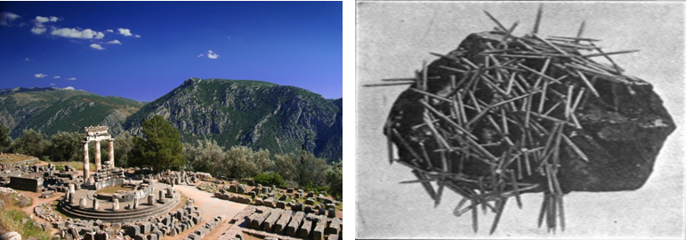

Magnets were first used as compasses and used by the Chinese in the 12th century.

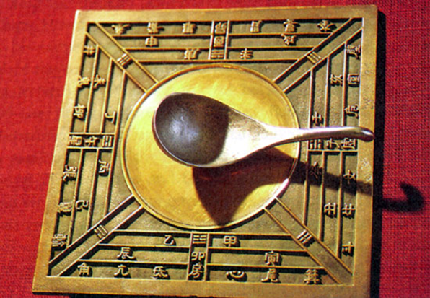

Magnets can attract **ferromagnetic materials** such as iron.

**Ferromagnetism**: physical phenomenon in which certain electrically uncharged materials strongly attract others. Two materials found in nature, lodestone (or magnetite, an oxide of iron, Fe3O4) and iron, can acquire such attractive powers, and they are often called natural **ferromagnets**.

In contrast to other substances, **ferromagnetic materials are magnetized easily**, and in strong magnetic fields the magnetization approaches a definite limit called **saturation**.

When a field is applied and then removed, the magnetization does not return to its original value—this phenomenon is referred to as **hysteresis**. When heated to a certain temperature called the **Curie point**, which is different for each substance, ferromagnetic materials lose their characteristic properties and cease to be magnetic; however, they become ferromagnetic again on cooling.

All magnets have a **north pole** and a **south pole**. In a simple bar magnet, a single north pole and a single south pole are located at opposite ends. A common horseshoe magnet is simply a bar magnet that is bent into a U shape – its poles are also its two ends.

**Like poles repel each other and opposite poles attract**

Magnets can attract or repel other magnets as shown in figure (1).



Fig. 1. Forces between a pair of bar magnets.

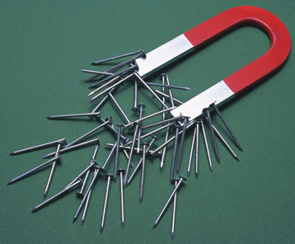

Magnets attract and pick up small pieces of iron.

When suspended, a long magnet turns until it points in a direction which runs roughly North-South, with the north pole of the magnet pointing towards the South.

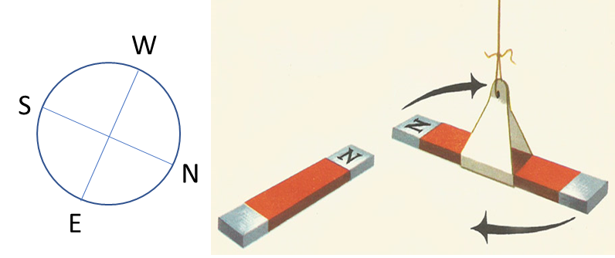

A compass needle or any other suspended magnet brought near a large magnet tends to turn towards the poles of the magnet.

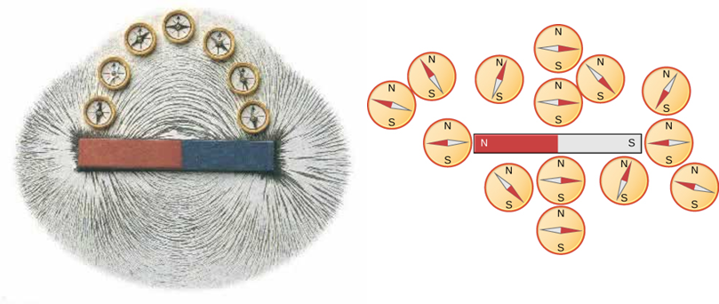

The compass needle shows the direction of the magnetic field lines.

**Magnetic field  [T tesla]**

To explain these magnetic forces, we introduce the concept of **magnetic field**  [T tesla].

**A field is a region of influence**. For example, an object because of its mass experiences a force in a gravitational field. A charged object experiences a force in an electric field. A **field** for a vector quantity is shown by a pattern of lines called **field lines**. The lines indicate the field pattern and the density of the lines indicates the strength of the field. The closer the field lines are together, then the stronger the field and hence the stronger the force.

A permanent **magnet** has a **north pole** and **south pole**. The magnetic field of a magnet can be shown by a set of continuous loops that exit from the north pole of the magnet and enter at the south pole as shown in figure (2), (3) and (4). The B-field lines indicate how a small magnet (or compass) will align itself in the field. Note: the magnetic field lines are continuous loops and pass through the magnet as shown in figure 2.

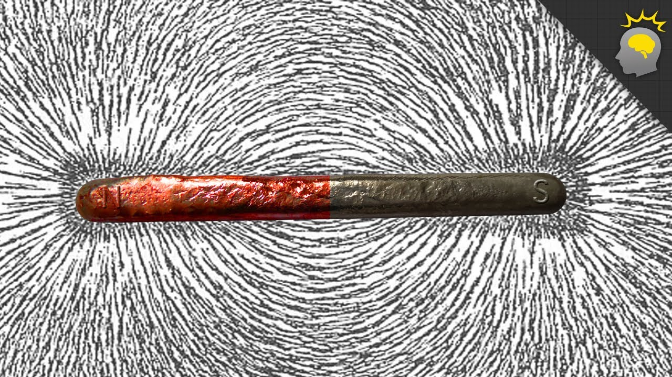



Fig. 2. Magnetic field lines for a bar magnet. The magnetic field lines are **continuous loops**. The field lines exit away from the north pole and enter the magnet at the south pole. The magnetic field is strongest where the field lines are closest together at the two poles.

[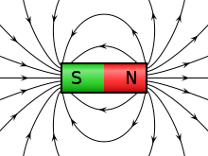](http://upload.wikimedia.org/wikipedia/commons/0/0c/VFPt_cylindrical_magnet_thumb.svg)[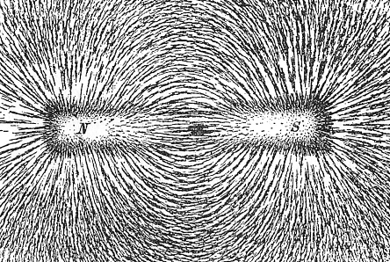](http://upload.wikimedia.org/wikipedia/commons/5/57/Magnet0873.png)

Fig. 3. Magnetic field lines for a bar magnet showing the external magnetic field only and the magnetic field pattern due to iron filings. The iron filings align themselves as if they were small magnets and more of them accumulate where the B-field is strongest.



Fig. 4. Magnetic field lines for a horse-shoe magnet. The magnetic field lines are continuous loops. The field lines exit away from the north pole and enter the magnet at the south pole.

The Earth has a magnetic field surrounding it. The field lines are similar to a huge bar magnet. The south pole of the magnet is located near the geographical north pole and the north magnetic pole near the south geographical pole as shown in figure (5).



Fig. 5. The Earth is surrounded by a magnetic field.

Figure 6 show that if you break a magnet into pieces you create smaller magnets.

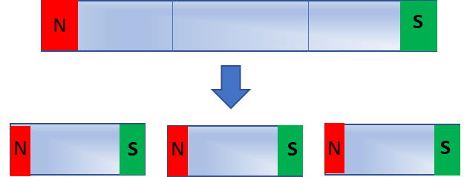

Fig. 6. Breaking a magnet produces new smaller magnets.

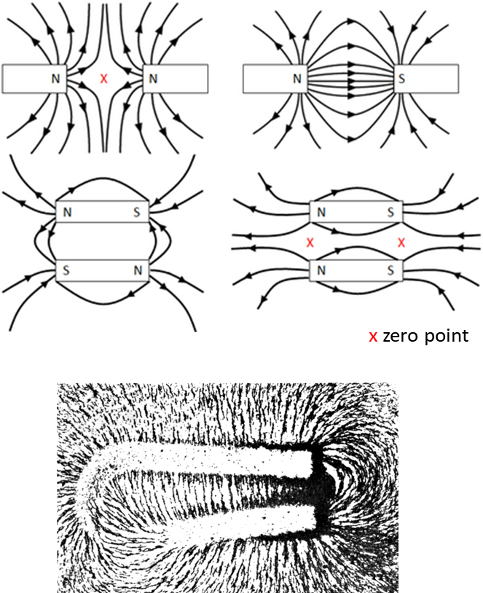

Magnetic field patterns for different arrangements of magnets.

Between a N-pole and a South-pole, the magnetic field lines run like clutching tentacles, hinting at an attractive force. Between N-pole and N-pole they spread and push against each other, hinting at repulsion. Nearer and near to a pole the magnetic field lines crowd closer and closer together, indicating increasing strength of the magnetic field.

**Magnetizing a rod**

New magnets can be made by rubbing rods of suitable materials with another magnet. This is the ancient way of making magnets – rubbing iron rods with lodestone.

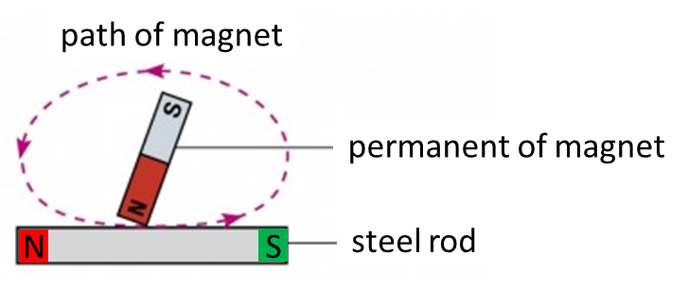

Today, a magnet is made by placing the rod inside a coil carrying a current called a **solenoid**.

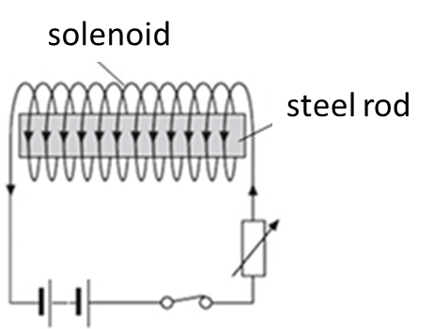

**Common uses of magnets**

* **Magnetic recording media**: VHS tapes and audio cassettes contain a reel of magnetic tape. The information that makes up the video and sound is encoded on the magnetic coating on the tape. Computers, floppy and hard disks record data on a thin magnetic coating.
* **Credit, debit, and ATM cards**: have a magnetic strip on one side.
* **Common televisions and computer monitors**: TV and computer screens containing a cathode ray tube employ an electromagnet to guide electrons to the screen.
* **Speakers and microphones**: Most speakers employ a permanent magnet and a current-carrying coil to convert electric energy (the signal) into mechanical energy (movement which creates the sound). The coil is wrapped around a bobbin attached to the speaker cone, and carries the signal as changing current which interacts with the field of the permanent magnet. The voice coil feels a magnetic force and in response moves the cone and changes the pressure the neighbouring air, thus generating sound. Dynamic microphones employ the same concept, but in reverse. A microphone has a diaphragm or membrane attached to a coil of wire. The coil rests inside a specially shaped magnet. When sound vibrates the membrane, the coil is vibrated as well. As the coil moves through the magnetic field, a voltage is induced across the coil. This voltage drives a current in the wire that is characteristic of the original sound.
* **Medicine**: Hospitals use Magnetic Resonance Imaging (MRI) to spot problems in a patient's organs without invasive surgery.
* **Transformers**: are devices that transfer electric energy between two windings of wire that are electrically isolated but are coupled magnetically.
* **Compasses**: is a magnetized pointer free to align itself with a magnetic field, most commonly Earth's magnetic field.
* **Art**: Vinyl magnet sheets may be attached to paintings, photographs, and other ornamental articles, allowing them to be attached to refrigerators and other metal surfaces.
* **Toys**
* Magnets can pick up magnetic items (iron nails, staples, tacks, paper clips) that are either too small, too hard to reach, or too thin for fingers to hold. Some screwdrivers are magnetized for this purpose. Magnets can be used in scrap and salvage operations to separate magnetic metals (iron, steel, and nickel) from non-magnetic metals (aluminium, non-ferrous alloys, etc.). The same idea can be used in the so-called magnet test, in which an auto body is inspected with a magnet to detect areas repaired using fiberglass or plastic putty.
* **Magnetic levitation transport**, or maglev, is a form of transportation that suspends, guides and propels trains through electromagnetic force. The maximum recorded speed of a maglev train is 581 km.h-1.
* **Health**: human tissues have a very low level of susceptibility to static magnetic fields, there is little mainstream scientific evidence showing a health hazard associated with exposure to static fields. Dynamic magnetic fields may be a different issue however; correlations between electromagnetic radiation and cancer rates have been postulated due to demographic correlations. If a ferromagnetic foreign body is present in human tissue, an external magnetic field interacting with it can pose a serious safety risk. A different type of indirect magnetic health risk exists involving pacemakers. If a pacemaker has been embedded in a patient's chest (usually for the purpose of monitoring and regulating the heart for steady electrically induced beats), care should be taken to keep it away from magnetic fields or metal detectors at airports. It is for this reason that a patient with the device installed cannot be tested with the use of an MRI, which is a magnetic imaging device. Children sometimes swallow small magnets from toys; and this can be hazardous if two or more magnets are swallowed, as the magnets can pinch or puncture internal tissues; one death has been reported.
* **Motors and generators**

[VISUAL PHYSICS ONLINE](http://www.physics.usyd.edu.au/teach_res/hsp/sp/spHome.htm)

If you have any feedback, comments, suggestions or corrections please email Ian Cooper

ian.cooper@sydney.edu.au

Ian Cooper School of Physics University of Sydney